Gas Leakage monitoring & Alerting system for Industries

**PROJECT PLANNING PHASE**

# Prepare Milestone and Activity List

|  |  |
| --- | --- |
| **Team ID** | **PNT2022TMID04012** |
| **Team Leader:** | **PRANAV S** |
| **Team member:** | **ARAVINDAN G**  **JAIKISHORE N**  **SHARATH KUMAR RG** |

Project Milestones

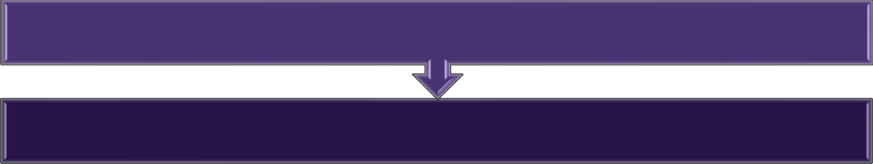

**PREPARATION PHASE**

**PROJECT DESIGN & PLANNING**

Ideation Phase Project Design Phase 1 Project Design Phase 2 Project Planning Phase

# Project Development Phase

Sprint 1 Sprint 2 Sprint 3 Sprint 4

FINAL DELIVERABLES

**ACTIVITY LIST**

|  |  |  |  |
| --- | --- | --- | --- |
| **Phase** | **Phase Description** | **Activity Number** | **Activity** |
| **1** | **Preparation Phase** (Prerequisites, Registrations, Environment Set-up, etc.) | 1.1 | Access the resources (courses) & guided project workspace |
| 1.2 | Register on IBM Academic Initiative & Apply Feature code for IBM Cloud Credits |
| 1.3 | Create GitHub account & collaborate with Project Repository in project workspace |
| 1.4 | Set-up the Laptop / Computers based on the prerequisites for each technology track |
| **2** | **Ideation Phase** (Literature Survey, Empathize, Defining Problem Statement, Ideation) | 2.1 | Literature survey on the selected project & Information Gathering |
|  |  | 2.2 | Prepare Empathy Map Canvas to capture the user Pains & Gains, Prepare list of problem statements |
|  |  | 2.3 | List the ideas by organizing the brainstorming session and prioritize the top 3 ideas based on the feasibility & importance |
| **3** | **Project Design Phase -I** (Proposed Solution, Problem- Solution Fit, Solution Architecture) | 3.1 | Prepare the proposed solution document, which includes the novelty, feasibility of idea, business model, social impact, scalability of solution, etc. |
|  |  | 3.2 | Prepare problem - solution fit document & Solution Architecture |
| **4** | **Project Design Phase -II** (Requirement Analysis, Customer  Journey, Data Flow Daigrams, Technology Architecture) | 4.1 | Prepare the customer journey maps to understand the user interactions & experiences with the application (entry to exit) |
|  |  | 4.2 | Prepare the Functional Requirement Document & DataFlow Daigrams |
|  |  | 4.3 | Prepare Technology Architecture of the solution |
| **5** | **Project Planning Phase** (Milestones & Tasks, Sprint Schedules ) | 5.1 | Prepare Milestone & Activity List, Sprint Delivery Plan |
| **6** | **Project Development Phase** (Coding & Solutioning, Acceptance  Testing, Performance Testing) | 6.1 | Project Development - Delivery of Sprint-1 |
|  |  | 6.2 | Project Development - Delivery of Sprint-2 |
|  |  | 6.3 | Project Development - Delivery of Sprint-3 |

|  |  |  |  |
| --- | --- | --- | --- |
|  |  | 6.4 | Project Development - Delivery of Sprint-4 |